# How to install a Windows VM

# using LXD

**從光碟安裝Windows虛擬機**

<https://ubuntu.com/tutorials/how-to-install-a-windows-11-vm-using-lxd>

Download iso and pack like below, a total 20G free disk is required.

**安裝distrobuilder套件及製作ISO**

|  |
| --- |
| $ sudo snap install distrobuilder --classic  $ sudo apt install genisoimage libwin-hivex-perl wimtools  $ sudo distrobuilder repack-windows WindowsIsoImage.iso win11.lxd.iso |

**製作範例**

|  |
| --- |
| lester@isorepack:~/Downloads$ sudo distrobuilder repack-windows Win11_23H2_Chinese_Simplified_x64v2.iso  win11.lxd.iso  INFO [2024-04-25T18:55:59+08:00] Mounting Windows ISO  mount: /var/cache/distrobuilder.2323481667/source: WARNING: source write-protected, mounted  read-only.  INFO [2024-04-25T18:55:59+08:00] Downloading drivers ISO  INFO [2024-04-25T19:08:17+08:00] Mounting driver ISO  mount: /var/cache/distrobuilder.2323481667/drivers: WARNING: source write-protected, mounted  read-only.  INFO [2024-04-25T19:08:17+08:00] Modifying WIM file file=boot.wim  index=2  Committing changes to /var/cache/distrobuilder.2323481667/overlay/sources/boot.wim (image 2)  Using LZX compression with 12 threads  Archiving file data: 19 MiB of 19 MiB (100%) done  INFO [2024-04-25T19:08:20+08:00] Modifying WIM file file=install.wim  index=1  Committing changes to /var/cache/distrobuilder.2323481667/overlay/sources/install.wim (image 1)  Using LZX compression with 12 threads  ...  Using DIRECTORYSERVICES_DOMAIN000.MAN;1 for  /var/cache/distrobuilder.2323481667/overlay/sources/replacementmanifests/directoryservices-domain  controller-tools-replacement.man  (directoryservices-domaincontroller-servercoreupg-replacement.man)  Size of boot image is 2880 sectors -> No emulation  0.15% done, estimate finish Thu Apr 25 19:09:00 2024  ...  99.98% done, estimate finish Thu Apr 25 19:09:15 2024  Total translation table size: 2048  Total rockridge attributes bytes: 0  Total directory bytes: 217088  Path table size(bytes): 2464  Max brk space used fe000  3410754 extents written (6661 MB)  INFO [2024-04-25T19:09:16+08:00] Removing cache directory  lester@isorepack:~/Downloads$ ls *.iso -lhs  6.4G -rw-rw-r-- 1 zlmao zlmao 6.4G Apr 25 18:16 Win11_23H2_Chinese_Simplified_x64v2.iso  6.6G -rw-r--r-- 1 root root 6.6G Apr 25 19:09 win11.lxd.iso  lester@isorepack:~/Downloads$ |

**主控台 🡪 建立一個VM**

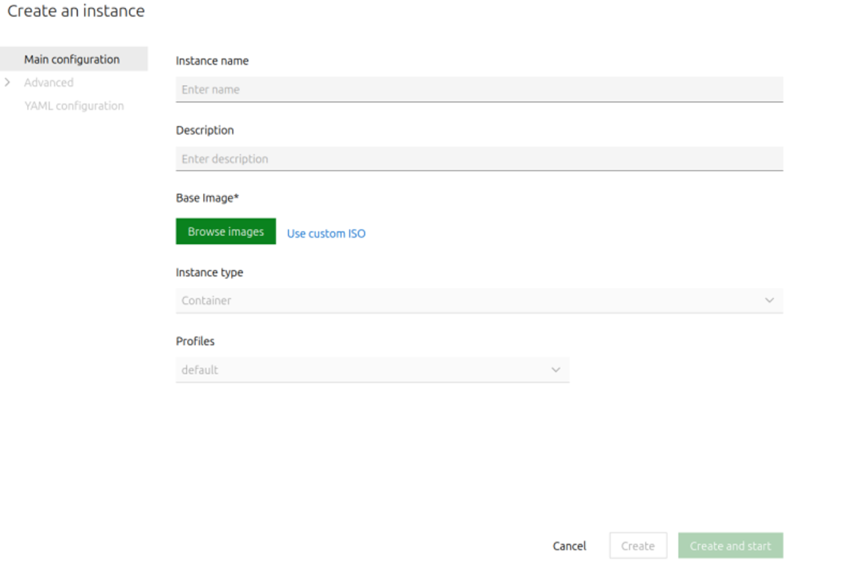

**選擇 Use custom ISO**

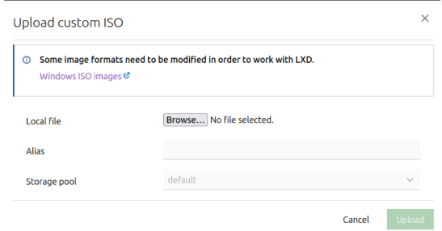

**點選Browser，選擇製作好的ISO檔，按下上傳Upload**

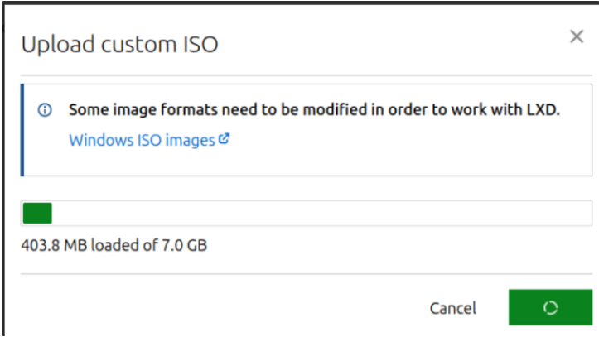

**VM資源配置：CPU、記憶體、硬碟及設定**



**滑鼠點擊、按下任意鍵，從 CD 或 DVD 啟動**

